Basic Instructions for Downloading Software

Relates to models:
Sitescan 123W/150/160/250,
Railscan 125,
MasterScan 350/380
PowerScan 450

Installation:
To install the software, unzip the file to a temporary directory, browse into the DISK1 directory, and run the Setup Application.

Use:
The sequence of operation is
- Start the Flaw Detector Downloader.
- Then press the ADVANCED tab so it looks like this

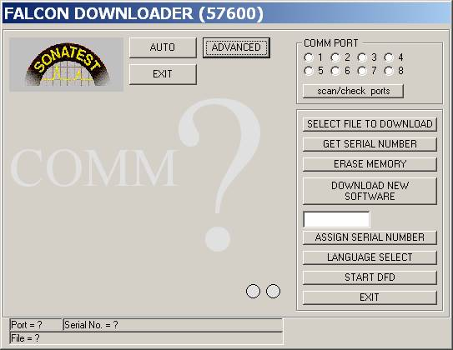

Put the Flaw Detector in download mode by turning it on with the “help” key pressed (until it goes through the self-test and displays “FAST DOWNLOAD RUNNING” on the screen.

Connect the PC to the Flaw Detector using the serial cable. (The USB connection does not support downloading software into the DFD)

Press the scan/check ports button on the downloader application. It should now say “DFD Found on Comm Port…

Press the “Get Serial number” button, to read the serial number from the Flaw Detector.

Now press the ERASE MEMORY button. The Application will say “The Memory is being erased, please wait.” When it has finished doing this (about 10 seconds) it will then say “The Memory Has Been Erased”.

Press “Select File to Download”, and browse to the .hex file that corresponds with the model number of your DFD.

Now press “Download New Software” This will take about three minutes to complete.

Check the serial number in the small window, press “Assign new Serial number”, and when that is done, the serial number is read back from the set and displayed on the Downloader.

Now, press the Language Select button. This will bring up a new panel on the PC which looks like this
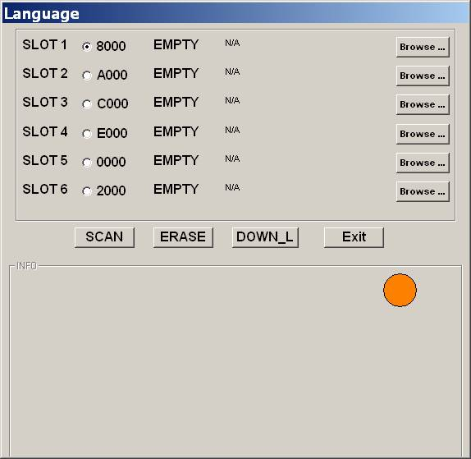

Use the browse button at the top to find the latest help_gb file, and press “DOWN_L”

The help file in English will be copied into the set. When that is finished. Add other languages or Press “Exit”. This will take you back to the original user interface on the PC.

Finally, press “Start DFD”

The DFD should start and run in the normal fashion. You can now press “Exit” on the downloader program.

